Clinical Mental Health Counseling
Program Evaluation Summary
2019-2020 Academic Year



Department of Psychology and Counseling

Master of Science in Clinical Mental Health Counseling
5601 19th Street, Suite #102
Lubbock, Texas 79407
1-806-720-7848

Logic Model for the CMHC 3-year Plan

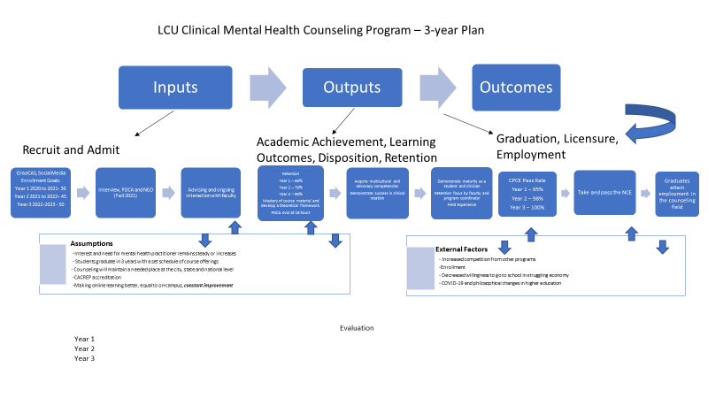

2019-2020 Admissions

Admitted and Enrolled: 22

Average GPA: 3.59

Current Student Population
Row Labels | Count of Ethnic Group
 | 2 | 3.08% | (Blank)
Asian | 2 | 3.08%
Black or African American | 5 | 7.69%
Hispanic | 9 | 13.85%
Nonresident Alien | 2 | 3.08%
Not Specified | 1 | 1.54%
White | 44 | 67.69%
Grand Total | 65

Current PPR Reviews completed over First 18 hours and clinical semesters
Student Gender | N | PIP Developed | No PIP Needed
Male | 3 | 1 | 2
Female | 35 | 5 | 30

PDCA – Faculty Evaluations

Faculty teaching Internship I and Internship II evaluate student dispositions using the PDCA. The results of the PDCA across all faculty ratings was a mean of 4.77 out 0f 5. Overall, student disposition falls into the above average range.

Past Site Supervisor Ratings for Students
Year | N | Communication Skills and Abilities | Professional Responsibility | Competence | Maturity | Integrity
2018-2019 | 51 | 1.94 | 1.98 | 1.97 | 1.99 | 1.98
2016-2017 | 4 | 1.8 | 2 | 2 | 2 | 2
2015-2016 | 7 | 1.9 | 2 | 2 | 2 | 2
2014-2015 | 3 | 1.9 | 2 | 2 | 2 | 2
2013-2014 | 7 | 2 | 2 | 2 | 2 | 2

Faculty and Supervisor Continuing Education

Each Spring, the Department of Psychology and Counseling offers the Healthy Families Conference at Lubbock Christian University. The conference presenters offer continuing education unites in ethics, current practice and trends in the community. The conference presenters are qualified to over CEUs for site supervisors, faculty supervisors, and practitioners.

Counselor Preparation Comprehensive Examination (CPCE) Scores
98% passing

ASSESSMENT FINDINGS
Program Strengths (Highest areas found in data)
- The counseling program at LCU consistently has CPCE scores above the National Average. The lower areas are above the national average as well.
- The full-time faculty have past and current clinical experience as mental health professionals in agencies or private practice.
- The student-teacher ratio is mentioned in the current and alumni comments as being a strength.
- Pursuing CACREP accreditation.
Program Weaknesses
- Communication was mentioned in the alumni and current student survey.
- Continuity between the course schedule and the class itself.
- Lack of diversity in student body.
- Address counseling individuals with special needs consistently throughout the program.
Areas of Improvement The overall quality of applicant has improved, likely due to the decision to remove Conditional Acceptance as an option for applicants who may not be a good fit for the program.
- Teaching assessment in counseling is a challenge, but the faculty who teach the course continue to add elements of real-world application to the course.
- Counseling research was added to the Fall schedule as a 16-week course, due to low scores on the CPCE and includes a more in-depth treatment of program evaluation and quantitative methods.
- Early in the Master’s in Counseling history, Multicultural Counseling was not required. Since adding the course to the program requirements, we have seen improvement on our CPCE scores for Multicultural Counseling and positive results in our students as well.
- Introduction to Mental Health Counseling and Advanced Techniques were added to the curriculum.
- For interviews and gatekeeping, we have started using the Professional Dispositions Competency Assessment as an additional data point for interviews, personal improvement plans and evaluations.
- Retention and recruiting

